The Corporation of the City of North Bay

By-Law No. 2021-59

A By-Law To Amend Zoning By-Law No. 2015-30 To Rezone Certain lands on Fourth Avenue East from a “Residential Third Density (R3)” Zone to a “Residential Sixth Density Special No. 135 (R6 Sp.135)” Zone

Deborah & Glenn Turcotte – 155 Fourth Avenue East

Whereas the owner of the subject property has initiated an amendment to the Zoning By-law;

And Whereas the Council of The Corporation of the City of North Bay has ensured that adequate information has been made available to the public, and held at least one public meeting after due notice for the purpose of informing the public of this By-law;

And Whereas it is deemed desirable to amend the zone designation shown on Schedule “B-52” of Zoning By-law 2015-30 pursuant to Section 34 of the Planning Act, R.S.O. 1990, c. P.13, as amended;

And Whereas Council passed Community Services Committee Report No. 2021-11 adopted by Council on June 29, 2021 by Resolution No. 2021-267 to approve this rezoning;

Now therefore the Council of The Corporation of the City of North Bay hereby enacts as follows:

- Schedule “B-52” of By-law No. 2015-30 is amended by changing the zoning designation of the property shown on Schedule “A” attached hereto (which property is more particularly described as PIN 49155-0624 (LT) LT 112 PL 62 Widdifield; North Bay; District of Nipissing), shown as hatched on Schedule A attached hereto from a “Residential Third Density (R3)” zone to a “Residential Sixth Density Special No. 135 (R6 Sp.135)” zone.
- All buildings or structures erected or altered and the use of land in such “Residential Sixth Density Special No. 135 (R6 Sp.135)” zone shall conform to all applicable provisions of By-law No. 2015-30 of The Corporation of the City of North Bay.
- Section 11 of By-law No. 2015-30 is amended by inserting at the end thereof the following Section 11.1.135:
"11.1.135 “Residential Sixth Density Special No. 135 (R6 Sp.135)” zone
11.1.135.1 The property description of this “Residential Sixth Density Special No. 135 (R6 Sp.135)” zone is PIN 49155-0624 (LT) LT 112 PL 62 Widdifield; North Bay; District of Nipissing along Fourth Avenue East in the City of North Bay as shown on the attached Schedule and on Schedule "B-52".
11.1.135.2 The regulations for this “Residential Sixth Density Special No. 135 (R6 Sp.135)” zone are as follows:
- Minimum lot area per dwelling unit of 144m2;
- Minimum lot frontage of 12.1 metres;
- Minimum front yard setback of 5.7 metres;
- Minimum side yard setback for a one storey structure of the existing 0.4 metres;
- Minimum side yard setback for a one storey structure of the existing 0.9 metres; and
- Minimum rear yard setback of 9.8 metres.

11.1.135.3 The use of land or building in this “Residential Sixth Density Special No. 135 (R6 Sp.135)” zone shall conform to all other regulations of this By-law, except as hereby expressly varied."
- Section 11 of By-law No. 2015-30 is further amended by inserting “Residential Sixth Density Special No. 135 (R6 Sp.135)” zone as shown on Schedule "A" to this By-law.
- Notice of the passing of this By-law shall be given by the Clerk of The Corporation of the City of North Bay in the manner and form and to the persons prescribed by Section 6 of O. Reg. 545/06 as amended.
- Any notice of appeal of this By-law shall be filed in accordance with the provisions of Section 34(19) of the Planning Act, not later than 20 days after the day that the giving of the notice by the Clerk is completed, setting out how the by-law is inconsistent with the policy statement issued under subsection 3(1), fails to conform with or conflicts with a provincial plan or fails to conform with an applicable official plan and shall be accompanied by the fee prescribed under the Local Planning Appeal Tribunal Act, S.O. 2017, c. 23, Sched. 1.
- Where no notice of appeal is filed with the Clerk within twenty (20) days as required by Section 6 of this By-law, then this By-law shall be deemed to have come into force on the day it was passed.

- Where one or more notices of appeal are filed with the Clerk within twenty (20) days in compliance with Section 6 of this By-law, then this By-law shall not come into force until all appeals have been finally disposed of in accordance with Section 34 of the Planning Act, whereupon the By-law shall be deemed to have come into force on the day it was passed.

Read a First Time in Open Council the 29th Day of June 2021.
Read a Second Time in Open Council the 29th Day of June 2021.

Read a Third Time in Open Council and Passed this 29th Day of June 2021.

_____________________________ ________________________________
Mayor, Allan McDonald Deputy City Clerk Jenn Montreuil

Schedule A
This is Schedule “A”
To By-law No. 2021-59

Passed the 29th Day of June 2021

_________________________
Mayor Allan McDonald

_________________________
Deputy City Clerk Jenn Montreuil

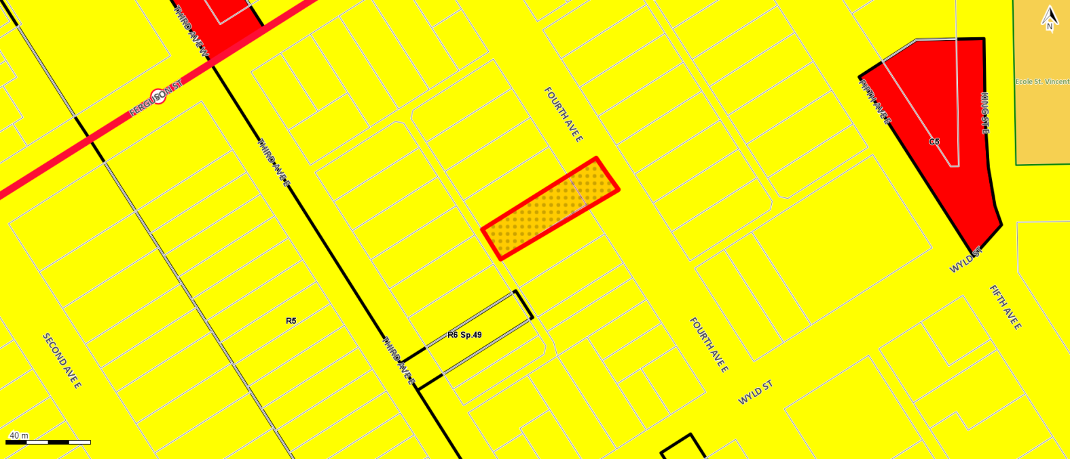
Legend

From a “Residential Third Density (R3)” zone to a ““Residential Sixth Density Special No. 135 (R6 Sp.135)” zone

Schedule B
This is Schedule “B”
To By-law No. 2021-59

Passed the 29th Day of June 2021

_________________________
Mayor Allan McDonald

_________________________
Deputy City Clerk Jenn Montreuil

